Y=A+B*C
A | B | C | B*C | A+B*C | Y
0 | 0 | 0 | 0 | 0 | 1
0 | 0 | 1 | 0 | 0 | 1
0 | 1 | 0 | 0 | 0 | 1
0 | 1 | 1 | 1 | 1 | 0
1 | 0 | 0 | 0 | 1 | 0
1 | 0 | 1 | 0 | 1 | 0
1 | 1 | 0 | 0 | 1 | 0
1 | 1 | 1 | 1 | 1 | 0

A

B

C

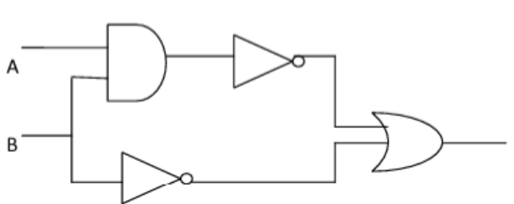

Y=A*B + B
A | B | A*B | B | Y
0 | 0 | 1 | 1 | 1
0 | 1 | 0 | 0 | 0
1 | 0 | 0 | 1 | 1
1 | 1 | 0 | 0 | 0

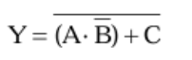

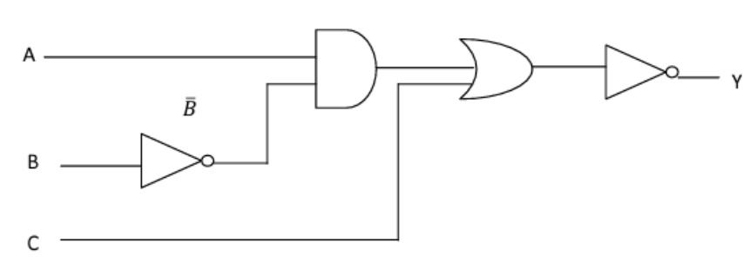

A | B | C | A*B | Y
0 | 0 | 0 | 0 | 1
0 | 0 | 1 | 0 | 0
0 | 1 | 0 | 0 | 1
0 | 1 | 1 | 0 | 0
1 | 0 | 0 | 1 | 0
1 | 0 | 1 | 1 | 0
1 | 1 | 0 | 0 | 1
1 | 1 | 1 | 0 | 0

